YMCA
2021 Community Giving Initiative Email Sample

Instructions:
The email template on page two is in a table format to make it easier for you to send. Please copy the whole table, paste it in your email and center it when you are ready to send.

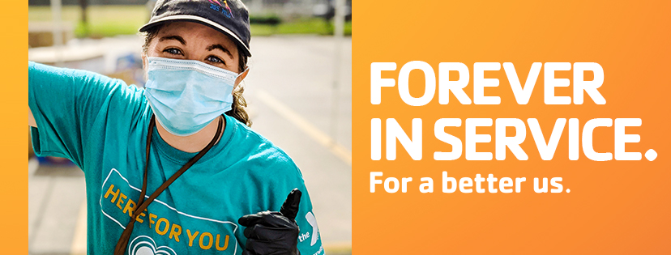
Dear Friends,
The Santa Monica Family YMCA would like to invite you to help us empower our community to become safer, healthier, and stronger. With your help, the YMCA can make that community a reality by keeping kids safe through drowning prevention, making adults healthier through chronic disease prevention programs that address diabetes, high blood pressure and cancer, and strengthening our youth’s future through YMCA Afterschool, Summer Camps, and leadership programs such as Youth and Government.
All of us have had moments in our lives which shaped our sense of who we are. I am proud to say that the Y is filled with staff and volunteers who work hard to help people discover those transformational moments and who truly believe that every person deserves the opportunity to reach their full potential.
I encourage you to embrace our vision for a Better Us. Help us construct the future we’re striving for by donating to the Y today. If you would like more information about the YMCA, ask me! I am fundraising for the Santa Monica Family YMCA and I would love to share my experience in making a difference.
DONATE

Sincerely,
Santa Monica Family YMCA Volunteer

